EXP NO . – 1.2

**NAME RAJDEEP JAISWAL UID – 20BCS2761**

**BRANCH – B.TECH (CSE) SEC/GROUP – 26(B)**

**SEMESTER – 2ND D.O.P – 3 MAY 2021**

**SUBJECT – COMPUTER WORKSHOP**

TOPIC. =

Tony Stark is in the planet Titan crying for his friends are turning into ashes, and on earth mayhem has ensued since a lot of people are turning into ashes too. Some trains have been derailed in such a way that a lot of its coaches are thrown off in a random disarray like coach 3, 4 and 5 are thrown off in one place, coach 2 and 6 are thrown off in another place, etc.

S.H.I.E.L.D calls upon Hulk and jarvis to help them collect and connect some the thrown off coaches of those trains, but a train can only move if the collected coaches number are in a continuous manner (need not to be in order) ,like 1234, 2314, 4123, 2341 etc.

Help Jarvis write a program for hulk to decide whether collected coaches will move or not.

**SOLUTION –**

**Input Format:**

**First line contains one number t, denoting the number of test cases.**

**Next t lines contain sequence of the collected coach numbers (n)**

**Output Format:**

**YES or NO (In capitals)**

**Input constraints:**

**1 <= t <= 10000**

**1<= n <= 1000000**

CODE IN TEXT FORM

#include <bits/stdc++.h>

using namespace std;

bool helpJarvis(string s)

{

vector<char> v;

for (int i = 0; i < s.size(); i++)

v.push_back(s[i]);

sort(v.begin(), v.end());

for (int i = 0; i < v.size() - 1; i++)

if ((v[i + 1] - v[i]) != 1)

return false;

return true;

}

int main()

{

string s = "4231";

bool ans = helpJarvis(s);

if (ans == true)

cout << "YES\n";

else

cout << "NO\n";

return 0;

}

CODE IN COMPILER / IDE –

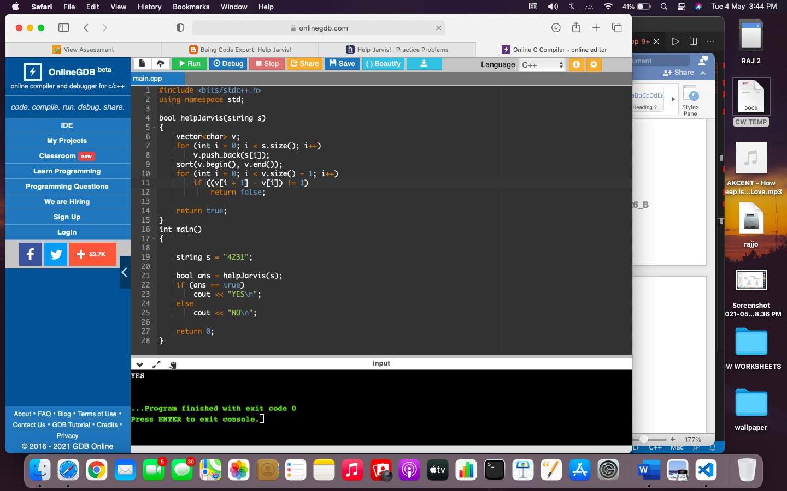

OUTPUT –

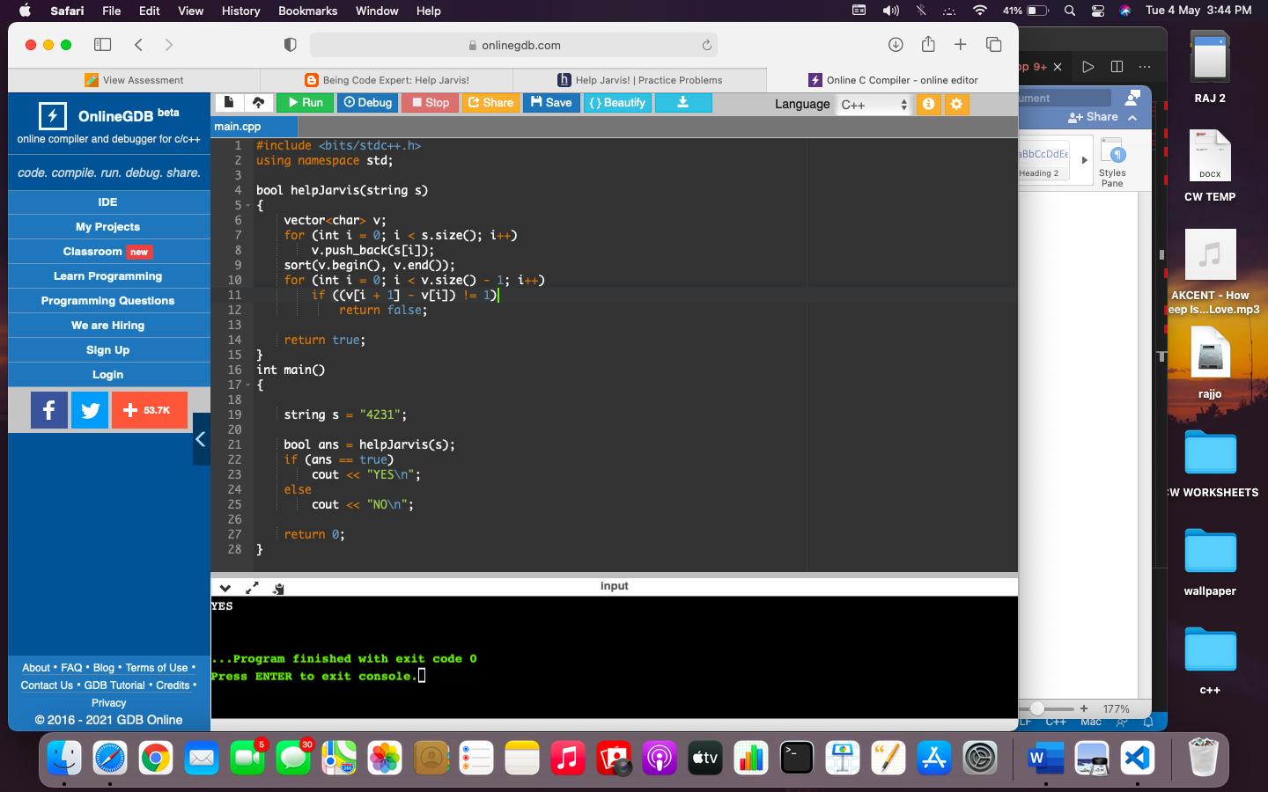

LEARNING OUTCOMES

1. Apply coding skills to solve application based problems on competitive platforms such as Hacker Rank/ Hacker Earth/Code Chef.
2. Understand the basic concept and structure of computer hardware
3. Identify the existing configuration of the computers and peripherals.
4. Installing and uninstalling multiple operating systems on a machine.
5. Apply their knowledge about computer peripherals to identify /rectify problems on-board.

EVALUATION COLUMN (To be filled by concerned faculty only)

|  |  |  |  |
| --- | --- | --- | --- |
| **Sr. No.** | **Parameters** | **Maximum**  **Marks** | **Marks**  **Obtained** |
| 1. | Worksheet Completion including writing learning objective/ Outcome | 10 |  |
| 2. | Post Lab Quiz Result | 5 |  |
| 3. | Student engagement in Simulation/ Performance/ Pre Lab Questions | 5 |  |
| 4. | Total Marks | 20 |  |